*ecse 211 design project*

Software Document

Version *1.03*

*03/29/2018*

*ECSE 211 TEAM 11*

VERSION HISTORY

|  |  |  |  |  |
| --- | --- | --- | --- | --- |
| **Title** | Software Document | | | |
| **Description** | Keeps track of all Software related implementation | | | |
| **Created By** | Bryan Jay, Project Manager & Volen Mihaylov, Software Manager | | | |
| **Date Created** | 2st March 2018 | | | |
| **Version Number** | **Modified By** | **Modifications Made** | **Date Modified** | **Status** |
| 1.00 | Patrick Ghazal | Created the Document. Asserted 3 possible preliminary designs coupled with their respective advantages/disadvantages | 2nd March, 2018 |  |
| 1.01 | Luka Jurisic | Peer reviewed the document. Formatted the Document. | 3rd March, 2018 | Preliminary Week 2 submission Content complete |
| 1.02 | Patrick Ghazal  Volen Mihaylov | Patrick-Added sections 3-Flowchart and 4-Class Diagrams.  Volen-Added Software Progress Report | 22nd March, 2018 | Everything up to milestone 2 is complete. The next step is to complete milestones 3,4 & 5 for the beta demo. |
| 2.00 | Enan Ashaduzzaman  Bryan Jay  Volen Mihaylov | Enan-Formatted the Document  Bryan Jay-Redid sections 2 & 4  Volen-Completed section 3- Flowchart | 29th March, 2018 | Everything up to milestone 6 is complete. The next step is to complete Milestone 7-Search and Localize. |

***Note*: Following the Beta Demo on 03/28/11, reasons outlining why we failed to meet the specifications are included in section 4.1***

TABLE OF CONTENTS

# 1 Table of ContentS ……………………………………………………………….3

# 2 Design Process ……………………………………………………………………

# 

# 3 Flowchart …………………………………………………………………………

# 4 Class Hierarchy

4.1 WIFI Data ………………………………………………………………………………

4.2 Robot ………………………………………………………………………………

4.3 Controller ………………………………………………………………………………

4.4 Localization …………………………………………………………………………

4.5 Odometer …………………………………………………………………

4.6 Navigation ………………………………………………………………………………

4.7 Light Detection …………………………………………………………………………

4.8 Search and Localize ……………………………………………………………………

# 5 JAVADOCS ………………………………………………………………………………

# 6 System architecture and integration …………………………………

# 7 edit history …………………………………………………………………………

# 8 Glossary ………………………………………………………………………………

# 2 DESIGN PROCESS

Before jumping into development, it is important to create the skeletons of our design base on the requirements and constraints imposed by the design project at hand. We generated a flow chart as a template for our software, as it visually demonstrated the interactions between our classes with one and another to create a solution. The requirements and specifications drove the development of all the classes and methods illustrated in the original diagram.

The first phase in development was to implement a versioning system in GitHub in order to record all future changes of code. We implemented a README file which outlined the way a proper commit was to be represented, as well as the software milestones. After completing our preliminary code, our software was then pushed forward into the testing phase. As each component was complete such as navigation, localization, etc. the testing team moved in parallel with the software team to test components. Throughout the testing phase our testing team implemented appropriate tests in order to test certain functionalities based on requirements. Based on feedback from the testing team certain improvements were made to the software and hardware.

|  |
| --- |
|  |

Figure 1: Excerpt from README

In order for our code to remain accessible and understandable, we used Javadocs for documentation. There are descriptions provided with every method and glass generated which is accessible on an HTML file for the team. The documentation allowed our multiple software engineers to be working on the code simultaneously, due to the fact that it was understandable for any new author working on the software.

# 3 flowchart

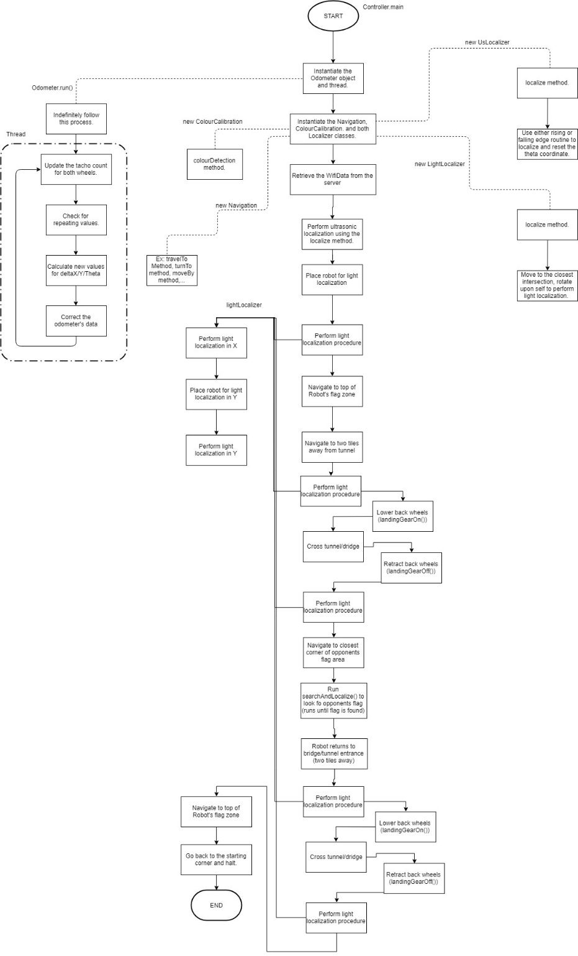

# 4 class hierarchy

Our software flowchart is then broken down into the following Class Hierarchy:

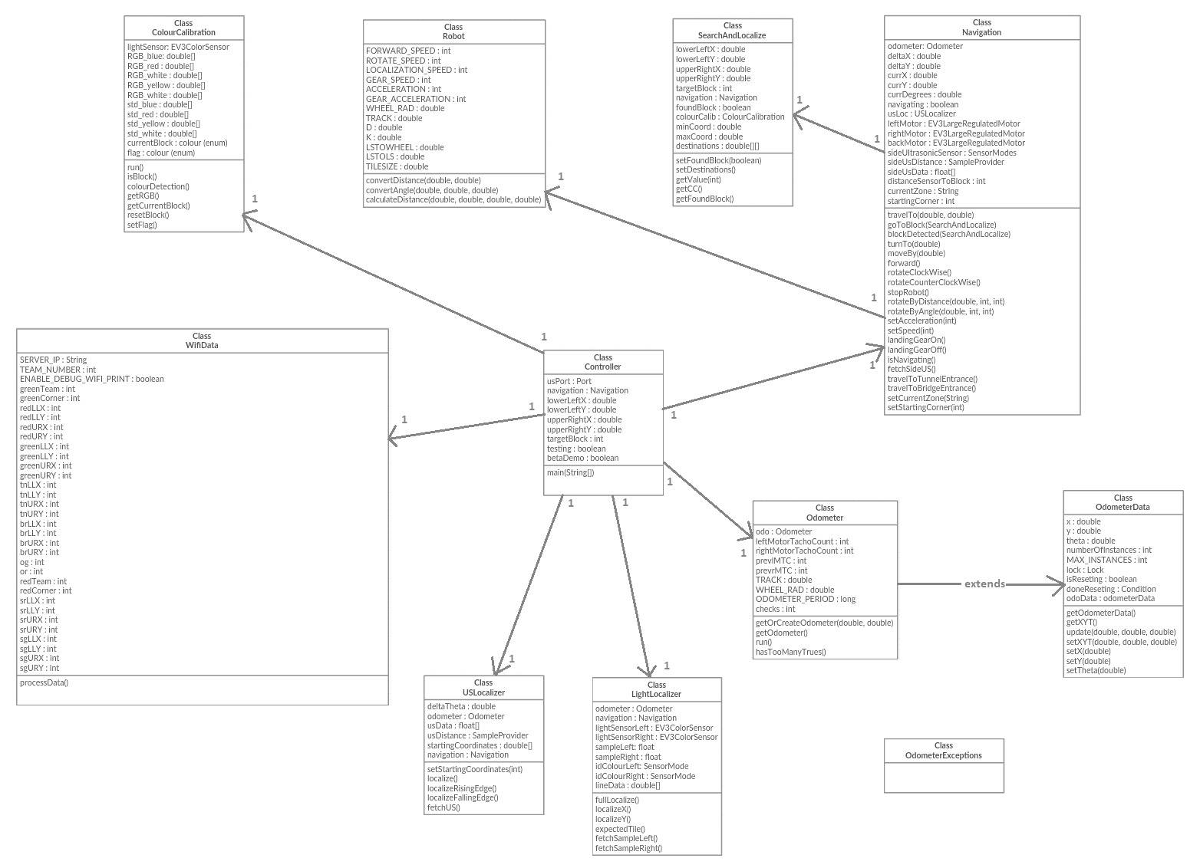

**4.1 WIFI Data**

The WIFI class is used as link between our robot and the computer. The class receives the data which our robot then uses to determine its team, its position, its target block and the location of the obstacles. The robot will complete the requirements based on the initial data forwarded to it.

**Beta Demo Failure:** Due to misnaming of certain variables in this class related to the XML file. During the beta demo, the robot failed to receive the data from the computer. Further edits in this class need to be made and then passed along to the testing team in order to be adjusted for the final demo.

**4.2 Robot**

The Robot class’ purpose is to contain and manage all the constants and variables related to the robot’s: motors, sensors, constants such as the track and wheel radius, etc. This allows for less memory to be used as the data will centralized and accessible by all classes limiting the repetition of variable compared to previously. In addition, the Robot class also includes the convertDistance, convertAngle, and calculateDistance methods, that are used namely for Navigation purposes.

**4.3 Controller**

The controller class is the main entry point into the software for the entire project, as it contains the main method relating to other classes. Using the controller class, we instantiate and declare the required threads and objects, respectively. Therefore, the controller class creates the central class which communicates with all other classes to run accordingly.

**4.4 Localization**

The light localizer class works jointly with the ultrasonic localization in order to determine the robot’s initial starting point and establish its heading and coordinates. The localization is used to set the robot’s X and Y coordinates and the heading based on the playing field. After completing localization, the robot is faced at 0˚ with the appropriate X and Y coordinates. The entire light localization process takes approximately 30 seconds to localize.

The initial US localization is used to set the heading of the robot using either a falling edge or rising edge method based on the distance of the US sensor. The falling edge is executed when the US sensor is faced away from the wall and vice versa. This routine rotates the robot on its axis recording the angle, α, at which it reaches a falling edge for the falling edge case and rising edge for the rising edge case and then it rotates the other direction and records β. The heading is then calculated from the recorded angles α, β using either one of the following equations:

$$∆θ=45-\frac{α+β}{2} if α<β$$

$$∆θ=225-\frac{α+β}{2} if α>β$$

The position and heading can be reset to its exact locations on the playing field due to the robot’s light localizer class. It is used at the beginning to calibrate its position and as well throughout the competition in order to correct the robots position. The robot utilizes the two light sensors equipped at each wheel in order to determine the robots offset when traversing a line. The delay between each light sensor recording the line is allows us to calculate the heading of the robot in either the X or Y direction. We calculate this offset using the following formula:

Throughout the course of the game when localization procedures repeat, the ultrasonic localization method is not performed as the robot will be capable of re-localizing using the lines on the playing field in order to skip that procedure and perform a variant of the light localization procedure. Therefore, we are able to decrease the robot’s error in position which is accrued through many factors such as friction, motor imperfections, sensor imperfections, etc.

**4.5 Odometer**

The odometer class is used to determine the estimated position of the robot by counting motor rotations. The odometer ignores physical experiences such a slip, friction, a constant wheel radius and wheelbase. Therefore, the omittance of such errors and flaws accumulated throughout the robot’s navigation and the error increases as the motor rotations increase. Localization must be performed multiple times throughout navigation around the playing field in order to update the odometer and reduce the effect of these error.

**4.6 Navigation**

The navigation class implements methods which moves the robot around the playing field and rotates its heading. The navigation procedure works very closely with the odometer as it relies on the odometer to move to its given locations. The navigation method works in tandem with odometry as the odometer is continuously being updated throughout its course. As well, throughout navigation, the ultrasonic sensor is continuously being run in order to avoid any collisions with possible robots.

**4.8 Search and Localize**

The colour detection class utilizes the Gaussian distribution approach to determine the colour of the blocks. In order to do this, we recorded the RGB readings from the light sensor on the different coloured blocks at close distances and using this data we calculated the mean and standard of deviation using the following formulas:

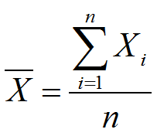

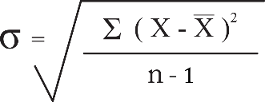

The color calibration determines whether or not the block’s readings are within the standard deviation of all three RGB values which deduces its color. This method is effective ad distances of 0-2 cm from the block.

**4.8 Search and Localize**

# 5 javadocs

# 6 system architecture and integrartion

# 7 edit History

|  |  |  |  |
| --- | --- | --- | --- |
| **Description** | Keeps track of modification of the final software code. | | |
| **Created By** | Volen Mihaylov, Software Manager | | |
| **Date Created** | 12th March, 2018 | | |
| **Version** | **Engineer** | **Summary** | **Date Modified** |
|  | Bryan Jay |  |  |
|  | Volen Mihaylov |  |  |
|  | Volen Mihaylov |  |  |
|  | Volen Mihaylov |  |  |

# 8 Glossary

The Application Programmer Interface was designed using JavaDoc comments on Eclipse and generated through it as well. The needed HTML files are included with the weekly reports as demanded. The API is updated as the code changes.